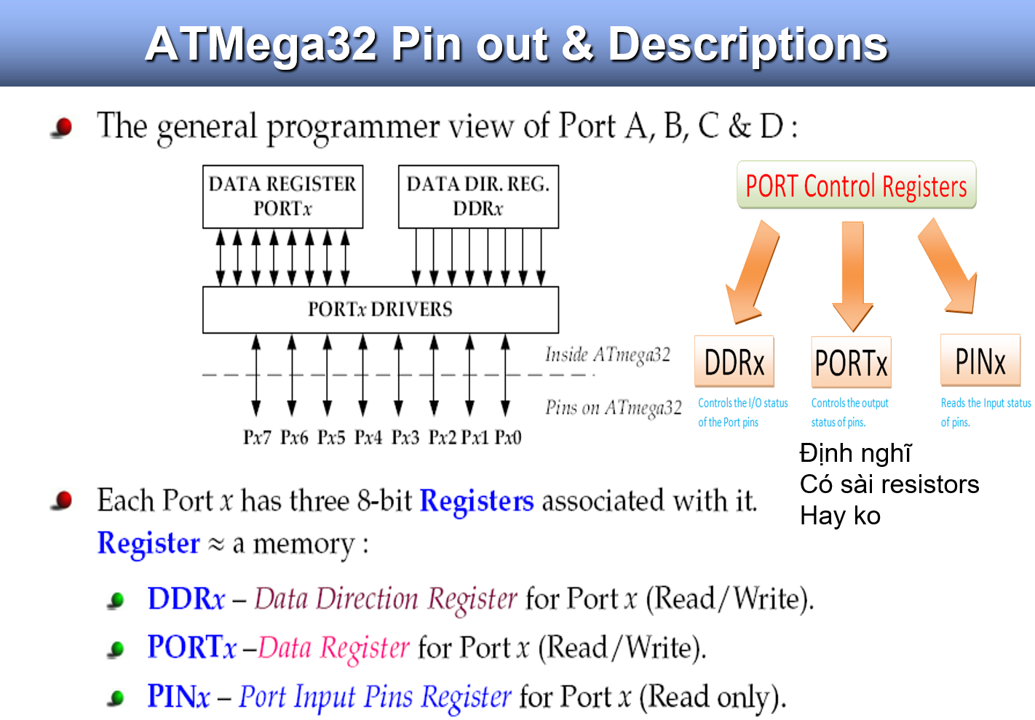

* There are some instructions for doing Arithmetic and logic operations; such as:

ADD, SUB, MUL, AND, etc.

* Write a program that calculates 19 + 95

**LDI R16, 19 ;R16 = 19**

**LDI R20, 95 ;R20 = 95**

**ADD R16, R20 ;R16 = R16 + R20**

* Write a program that calculates 19 + 95 + 5

**LDI R16, 19 ;R16 = 19**

**LDI R20, 95 ;R20 = 95**

**LDI R21, 5 ;R21 = 5**

**ADD R16, R20 ;R16 = R16 + R20**

**ADD R16, R21 ;R16 = R16 + R21**

**LDI R16, 19 ;R16 = 19**

**LDI R20, 95 ;R20 = 95**

**ADD R16, R20 ;R16 = R16 + R20**

**LDI R20, 5 ;R20 = 5**

**ADD R16, R20 ;R16 = R16 + R20**

* Only registers in the range R16 to R31 can be loaded immediate.
* LDI - We cannot load a constant into the registers R0 to R15 directly. It would have to be loaded into a valid register first then copied. To load the value of 10 into register zero (R0):

🡪

LDI R16,10       ; Set R16 to value of 10   
MOV R0, R16    ; Copy contents of R16 to R0



